For Office Use ONLY
Date Received: _______________
Income Review: ______________
Employment Reviewed:________
Approved or Denied
PRIME APPLICATION
Property Address: ______________________________________________

______________________________________________________________

Please complete all requested information on this form. Thank you for your interest in our company.
Date of Application: _________________ Desired Date of Occupancy: ____________________

I have $________________ to put down today in: Money Orders / Certified Funds / Credit Card (5% surcharge)

PERSONAL INFORMATION
APPLICANTS FULL NAME: __________________________________________________________________
Date of Birth: _____________________ Social Security # : _____________________________
Driver’s License No. & State: _______________________________________________________________

CO-APPLICANTS FULL NAME: _______________________________________________________________
Date of Birth: _____________________ Social Security # : _____________________________
Driver’s License No. & State: _______________________________________________________________

Have you or co-applicant ever filed for Bankruptcy? YES / NO (Circle One)
Do you have any family or friends that are customers of Prime? YES / NO (Circle One)
If so, who? : _____________________________________________________________________
Have you ever rented or leased a Prime house? YES / NO (Circle One)
If so, which one? : ____________________________________________________________________
Do you have any pets? _________________________ If so, how many? ________________________________
What kind of pet, breed, weight and age? ___________________________________________________________
____________________________________________________________________________________________ How did you hear about the property? (newspaper, internet, sign, referral)_______________________________
- APPLICATIONS WILL NOT BE PROCESSED WITHOUT THE APPLICATION FEE AND REQUESTED DOCUMENTS.
- YOU MUST BE ABLE TO PROVIDE PROOF OF RENTAL HISTORY PAYMENTS IN THE FORM OF MONEY ORDERS OR CLEARED CHECKS.
- YOU MUST HAVE A DEPOSIT IN THE FORM OF MONEY ORDER OR CERTIFIED CHECK FOR US TO HOLD THE PROPERTY IN YOUR NAME UNTIL CLOSING.
Revised 7/19 LM

RESIDENCE HISTORY

PRESENT ADDRESS: ________________________________________________________________

Dates From: _______________ to ______________ Home #: _________________________________

Applicant’s Cell # : __________________________Co-Applicant’s Cell # :________________________

Email Address: ________________________________________________________________________

Current Landlord or Mortgage: _______________________________ Phone # : ____________________

Monthly Payment $ __________________ Reason for Moving : _________________________________

PREVIOUS ADDRESS: ________________________________________________________________

Current Landlord or Mortgage: _______________________________ Phone # : ____________________

Monthly Payment $ __________________ Reason for Moving : _________________________________

EMPLOYMENT INFORMATION

PRESENT EMPLOYER: ________________________________ From:__________To:___________

Employer’s Address: ______________________________________ Phone # _____________________

Position: _________________ Supervisor: ____________________Gross Monthy Salary $__________

PREVIOUS EMPLOYER: _______________________________ From:__________To:___________

Employer’s Address: ______________________________________ Phone # _____________________

Position: _________________ Supervisor: ____________________Gross Monthy Salary $__________

CO-APPLICANTS EMPLOYER: ________________________________ From:________To:_________

Employer’s Address: ______________________________________ Phone # _____________________

Position: _________________ Supervisor: ____________________Gross Monthy Salary $__________

********** EMERGENCY CONTACT INFORMATION: **********

Parents Contact Info - Name: ______________________________________________________

Address: __________________________________________ Phone # _______________________

Nearest Relative (Not living with you) Name:___________________________________________

Address: __________________________________________ Phone # _______________________

Verified by PFS __________
Revised 7/19 LM
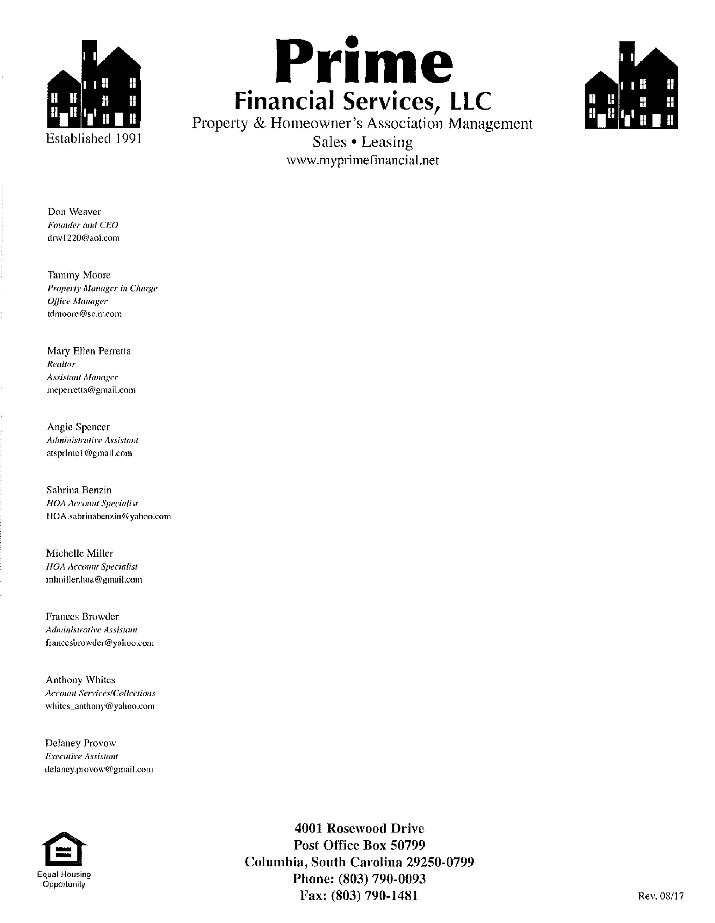

Revised 7/19 LM

RENTAL/EMPLOYMENT VERIFICATION REQUEST FORM

Name:__________________________________________________
____________

Present Address:______________________________________________________

**********************************************************************

RENTAL VERIFICATION

Current Payment Amount $ ___________

Landlord Name:
_______________________ Phone # _______________________

Number of late payments within the last twelve months (over 30 days)___________

How long at this current address? ____________

X______________________________________ ______________________
__

EMPLOYMENT VERIFICATION

Name of Company ______________________________ Phne # _____________________

How long employed here? _______________ Monthly Salary $ _____________________

X __________________________________________
_________________________

**********************************************************************

I hereby authorize Prime Financial Services to verify my past and present
employment. I further authorize Prime Financial Services to verify oth
er
information, including past and present mortgage and Landlord references.

SSN# ______________________

Signature: ____________________________________
__
_

Date:_______________

Landlord Signature

Date

Employer Signature

Date

Housing % Amt ______________

(
1.2)
Current Pmt X

Income % Amt
_______________

(
30)
Monthly Inc. X .

*Managers initials if exceeds guidelines*

** For Office Use Only **

Requested By: ________________________

Property Address: _____________________

____________________________________

POWER, WATER/SEWER AND LEGAL RESIDENCY REQUIREMENTS

Your property will be located at : ____________________________________

_______________________________________________________________

_______ Richland County _______ Lexington County

**Please be advised that prior to signing your lease, YOU must do the following:

Water/Sewer Company:
- BEFORE signing you will need to contact the water company to have water put into your name. You must provide a letter to Prime that water is active and in YOUR name.

Power Company:
- BEFORE signing Contact the power company and put in an order to transfer power into your name at your new address.
- Obtain the Address and Service Verification Letter from the power company and provide it with us.

Signature: ________________________________________________ Date : _____________________

Signature: ________________________________________________ Date : _____________________

Revised 7/19 LM

PRIME FINANCIAL SERVICES
Property & Homeowner’s Association Management
Sales ~ Leasing www.myprimefinancial.net

TO NEW PRIME FINANCIAL CUSTOMERS:
*** For the convenience, this is a list of company names YOU, may have to contact to transfer your utilities into your name depending on your new address.
WATER:
_____ 1. City of Columbia………………………………………………………..… 803-545-3300
_____ 2. Carolina Water Services – Lexington ...……………………...…...……. 1-800-272-1919
_____ 3. West Columbia Water Department ……………………………………..… 803-791-1880
_____ 4. Richland County Finance ……………………………………………….… 803-576-2099
_____ 5. Town of Lexington Utility Department …………………………………….803-359-2434
_____ 6. Lexington Joint Water & Sewer ……………………………………….….. 803-359-8373

_____ 1. City of Columbia ………………………………………………….…….…803-545-3300
_____ 2. Midlands Utilities …………………………………………………….….... 803-359-4803
_____ 3. Richland County Finance …………………………………………….…… 803-576-2099
_____ 4. Palmetto Utilities ………………………………………………..….…….. 803-699-2422
_____ 5. Carolina Water ……………………………………………………….… 1-800-272-1919
_____ 6. East Richland County ………………………………….…………………. 803-788-1570

SEWER:

POWER & GAS:
_____ 1. SCE&G ………………………………………………………………….. 1-800-251-7234
_____ 2. Mid-Carolina ………………………………………………………….…… 803-749-6400
MAILBOX KEYS ~ If you have a locking mailbox, YOU must get the key from your local post office.
*** YOU MUST HAVE WATER AND SEWER TRANSFERRED INTO YOUR NAME AFTER SIGNING THE LEASE OR IT WILL BE CUT OFF.
REGIME: Company: ______________________________________________
Contact Person: __________________________________________________
Phone # _________________________________________________________

Signature: ___________________________________________________________ Date: _________________________

Signature: ___________________________________________________________ Date: _________________________

Revised 7/19 LM
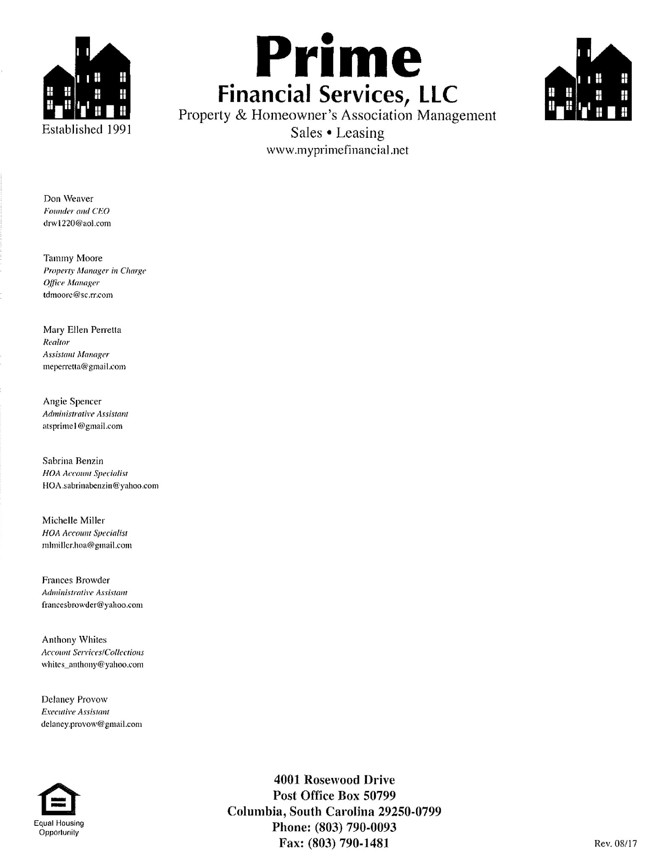

RENTAL DEPOSIT AGREEMENT

I hereby authorize Don Weaver/Prime Financial Services to hold funds on the property located at

_____________
_______________________
______________
, as deposit. I ___________________________
agree to provide

all requested items to complete my application within 3 days or my deposit will not be
refunded. Requests for a refund must be made in writing within 3 days from the date of this agreement.

*Please Note:

Signings

must be no later than 3 weeks from date o
f initial deposit unless otherwise noted. ________
(
Initials
)

Deposit Date: _______________ Expected
Date of Signing
:
__________________

*Deposits will be 100% refunded in cases where a cred
it applications has been denied, unless the
applicant provided fals
e information.

Rental Amount of Property:

____________________

Security Deposit
:

____________________

Application Fee:

____________________
*Non
-
Refundable * Pet Deposit: $ ___________

Amount Paid:

_
___________________

Date: ____________________

Payment to Begin On:
____________________

Total Amount Due at
Signing

$
___
_________________

I understand Prime Financial Services will do a public index search online in order to ve
rify
that no “Rule to Vacate” actions have been filed on me in the past. If the verification reveals
that actions have been filed and Prime Financial Services was not made aware of this prior to
signing this agreement, a $250 administrative fee will be tak
en out of my deposit.

Renter’s Contact

Information
:

Cell: _______________________ Home: _________________________

Work: _____________________ Email: _______________________________________________

__________________________________

___________________________________

Buyer’s Signature

Witness

__________________________________

____________________

Date

Date

** For Office
Use Only **

Completed by:

________ (initials)

Revised 11/7 ATS

APPROVED BY:

________________
_

Date:
____________

Revised 7/19 LM

