Please complete all requested information on this form. Thank you for your interest in our company.
Date of Application: _________________ Desired Date of Occupancy: ____________________

I have $________________ to put down today in: Money Orders / Certified Funds ONLY

PERSONAL INFORMATION
APPLICANTS FULL NAME: __________________________________________________________________
Date of Birth: _____________________ Social Security # : _____________________________
Driver’s License No. & State: _______________________________________________________________

CO-APPLICANTS FULL NAME: _______________________________________________________________
Date of Birth: _____________________ Social Security # : _____________________________
Driver’s License No. & State: _______________________________________________________________

Have you or co-applicant ever filed for Bankruptcy? YES / NO (Circle One)
Do you have any family or friends that are customers of Prime? YES / NO (Circle One)
If so, who? : _________________________________________________________________________
Have you ever rented or leased a Prime house? YES / NO (Circle One)
If so, which one? : ____________________________________________________________________
Do you have any pets? _________________________ If so, how many? ________________________________
What kind of pet, breed, weight and age? ___________________________________________________________
____________________________________________________________________________________________
How did you hear about the property? (newspaper, internet, sign, referral)_______________________________
- APPLICATIONS WILL NOT BE PROCESSED WITHOUT THE APPLICATION FEE AND REQUESTED DOCUMENTS.
- YOU MUST BE ABLE TO PROVIDE PROOF OF RENTAL HISTORY PAYMENTS IN THE FORM OF MONEY ORDERS OR CLEARED CHECKS.
- YOU MUST HAVE A DEPOSIT IN THE FORM OF MONEY ORDER OR CERTIFIED CHECK FOR US TO HOLD THE PROPERTY IN YOUR NAME UNTIL CLOSING.

Property Address: ______________________________________________

______________________________________________________________
PRIME APPLICATION
For Office Use ONLY
Date Received: ___________________
Income Review: __________________
Employment Reviewed:____________
Approved or Denied
RESIDENCE HISTORY

PRESENT ADDRESS: ________________________________________________________________

Dates From: _______________ to ______________ Home #: _________________________________

Applicant’s Cell # : __________________________Co-Applicant’s Cell # :________________________

Email Address: ________________________________________________________________________

Current Landlord or Mortgage: _______________________________ Phone # : ____________________

Monthly Payment $ __________________ Reason for Moving: _________________________________

PREVIOUS ADDRESS:________________________________________________________________

Current Landlord or Mortgage: _______________________________ Phone # : ____________________

Monthly Payment $ __________________ Reason for Moving: _________________________________
EMPLOYMENT INFORMATION

PRESENT EMPLOYER: ________________________________ From:__________To:___________

Employer’s Address: ______________________________________ Phone # _____________________

Position: _________________ Surpervisor: ____________________Gross Monthy Salary $__________

PREVIOUS EMPLOYER: _______________________________ From:__________To:___________

Employer’s Address: ______________________________________ Phone # _____________________

Position: _________________ Surpervisor: ____________________Gross Monthy Salary $__________

CO-APPLICANTS EMPLOYER: ________________________________ From:________To:_________

Employer’s Address: ______________________________________ Phone # _____________________

Position: _________________ Surpervisor: ____________________Gross Monthy Salary $__________
********** EMERGENCY CONTACT INFORMATION: **********

Parents Contact Info - Name: ______________________________________________________

Address: __________________________________________ Phone # _______________________

Nearest Relative (Not living with you) Name:___________________________________________

Address: __________________________________________ Phone # _______________________

Verified by PFS __________

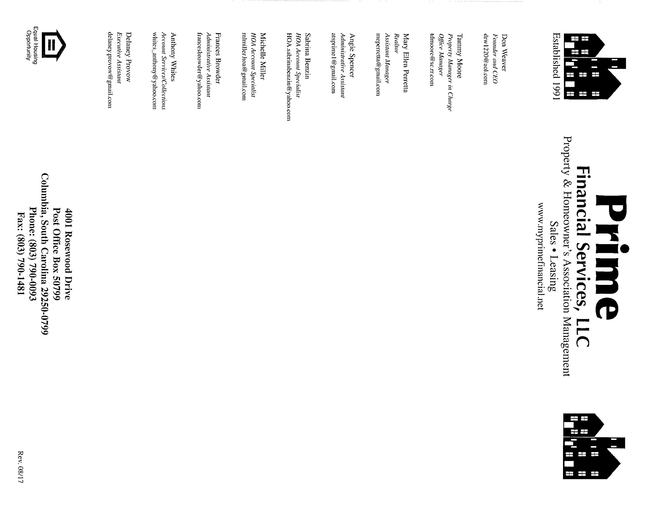

** For Office Use Only **
Requested By: ________________________
Property Address: _____________________
____________________________________
Housing % Amt ______________
(Current Pmt X 1.2)
Income % Amt _______________
(Monthly Inc. X .30)
*Managers initials if exceeds guidelines*
Landlord Signature Date
Employer Signature Date
RENTAL/EMPLOYMENT VERIFICATION REQUEST FORM

Name:______________________________________________________________
Present Address:______________________________________________________
**********************************************************************
RENTAL VERIFICATION Current Payment Amount $ ___________
Landlord Name: _______________________ Phone # _______________________
Number of late payments within the last twelve months (over 30 days)___________
How long at this current address? ____________
X______________________________________ ________________________

EMPLOYMENT VERIFICATION
Name of Company ______________________________ Phne # _____________________
How long employed here? _______________ Monthly Salary $ _____________________
X __________________________________________ _________________________
**********************************************************************
I hereby authorize Prime Financial Services to verify my past and present employment. I further authorize Prime Financial Services to verify other information, including past and present mortgage and Landlord references.
SSN# ______________________
Signature: _______________________________________ Date:_______________
Addendum to Deposit Agreement

Marriage Status: * Sign which one applies to you *

- I confirm that I have never been married.

Purchaser: __________________________________________ Date:______________________

- I confirm that I am still currently married and my spouse will be living with me.

Purchaser: __________________________________________ Date:______________________

- I confirm that I am legally separated or am divorced and have court signed documentation to back this up.
(You may be required to provide this if the tax assessor requests it.)

Purchaser: __________________________________________ Date:______________________

Home Ownership: * Sign which one applies to you *

- I confirm I do NOT own a home.

Purchaser: __________________________________________ Date:______________________

- I confirm that neither party has a home in their name (Whether Married, Divorced, or Separated)

Purchaser: __________________________________________ Date:______________________

- I confirm that I am currently married/not legally separated or I/we currently owns another home. I understand that my taxes will be an additional $150 per month, because I will not be able to claim the 4% legal residence, at the county Tax Assessors Office.

Purchaser: __________________________________________ Date:______________________

*** Please be advised that you may have to provide proof that you reside at the property. You may be asked to provide a letter from your electric company that service is in your name. You are REQUIRED to change your Driver’s License to the address you are purchasing before the day of signing. You may be asked to change your vehicle information by the county. ***

*****************************************************************
I authorize Prime Financial Services to contact SCE&G or Mid-Carolina to obtain a written Address and Service Verification Letter that I/We have services in our name, after signing.

Property Address to be verified is: _________________________________________________________________

Purchaser: _____________________________________________ Date: _________________

LEGAL RESIDENCY AND POWER, WATER/SEWER REQUIREMENTS

Your property will be located at: _________________________________________________________
_____________________________________________________________________________________

**Please be advised that PRIOR to signing, YOU MUST do the following:

SC DMV:
- BEFORE signing, you must change your SC Driver’s License, voters registration and vehicle registration to reflect the new address of the property you are purchasing. We must have this before you may sign your lease purchase.
Power Company:
- BEFORE signing contact the power company and put in an order to transfer power into your name at your new property address to coincide with your scheduled signing date.
- BEFORE signing obtain the Address and Service Verification Letter from the power company and have them fax a copy to our office #790-1481; BEFORE SIGNING or we will not be able to complete your signing as scheduled.

Water/Sewer Company:
- AFTER signing you will need to contact the water company to have water put into your name. You must provide a letter to Prime that water is active and in YOUR name.

(FOR RICHLAND COUNTY ONLY) Legal Residency:
- BEFORE signing Richland County Assessor requires that you submit an application for legal residency online at https://www6.richlandcountysc.gov/assessorapps/
The county will also require that you upload the following documents. SC Driver’s License, Social Security Card, Voters Registration, Vehicle Registration and Tax returns. If not; the county will increase your property taxes causing your monthly payment to go up by $150+ a month.

Signature: ____________________________________________________ Date : _____________________

Signature: ____________________________________________________ Date : _____________________

PRIME FINANCIAL SERVICES
Property & Homeowner’s Association Management
Sales ~ Leasing
www.myprimefinancial.net

Property Address: _______________________________________________________________________________________

*** For the convenience, this is a list of company names YOU, may have to contact to transfer your
utilities into your name depending on your new address.
WATER:
_____ 1. City of Columbia………………………………………………………..… 803-545-3300
_____ 2. Carolina Water Services – Lexington ...……………………...…...……. 1-800-272-1919
_____ 3. West Columbia Water Department ……………………………………..… 803-791-1880
_____ 4. Richland County Finance ……………………………………………….… 803-576-2099
_____ 5. Town of Lexington Utility Department …………………………………….803-359-2434
_____ 6. Lexington Joint Water & Sewer ……………………………………….….. 803-359-8373
SEWER:
_____ 1. City of Columbia ………………………………………………….…….…803-545-3300
_____ 2. Midlands Utilities …………………………………………………….….... 803-359-4803
_____ 3. . Richland County Finance ………………………………………….…… 803-576-2099
_____ 4. Palmetto Utilities ………………………………………………..….…….. 803-699-2422
_____ 5. Carolina Water ……………………………………………………….… 1-800-272-1919
_____ 6. East Richland County ……………………………………………….……. 803-788-1570
POWER & GAS:
_____ 1. SCE&G ………………………………………………………………….. 1-800-251-7234
_____ 2. Mid-Carolina ………………………………………………………….…… 803-749-6400
MAILBOX KEYS ~ If you have a locking mailbox, YOU must get the key from your local post office.
*** YOU MUST HAVE WATER AND SEWER TRANSFERRED INTO YOUR NAME AFTER SIGNING THE LEASE OR IT WILL BE CUT OFF.
REGIME: Company: ______________________________________________
Contact Person: __________________________________________
Phone # ________________________________________________

Signature: ___________________________________________________________ Date: _________________________

Signature: ___________________________________________________________ Date: _________________________

\
\

F;lgskjfd;lkjg

PURCHASE AGREEMENT
I hereby authorize Don Weaver/Prime Financial Services to hold funds on the property located at

___________________________________________________________________________ .

Request for a refund must be made in writing within (3) business days. There will be NO refunds issued after (3) business days.

*Please Note:
Signings must be no later than 3 weeks from date of initial deposit unless otherwise noted. ________(initials)

Deposit Date: _______________ Expected Date to Sign: __________________

*Deposits will be 100% refunded in cases where a credit applications has been denied.

Purchase Price of Property: ____________________
Amount of Payments: ____________________
Full Payment to Begin On: ____________________
Down Payment: ____________________
Application Fee: ____________________ *Non-Refundable*
Pro-Rated/1st Month Due: ____________________
Signing Cost: ____________________
Total Amount of Loan: ____________________
Amount Paid: ____________________ Date: ____________________
Total Amount Due at Signing $ _____________________
I understand Prime Financial Services will do a public index search online in order to verify that no “Rule to Vacate” actions have been filed on me in the past. If the verification reveals that actions have been filed and Prime Financial Services was not made aware of this prior to signing this agreement, a $250 administrative fee will be taken out of my deposit.
Buyers Contact: Cell: _______________________ Home: _________________________
Work: _____________________ Email: _______________________________________________

__________________________________ ___________________________________
Buyer’s Signature Witness

________________________ _______________________
Date Date

** Approved By **

Date:_____________

** For Office Use Only **
Completed by:
________ (initials)

Revised 11/9/2017

